**Walkthrough: Setting up your storage mode**

**Introduction**

So far you learned that Power BI is a powerful data visualization tool that can help you turn raw data into insightful reports and dashboards. However, before you can start creating visuals, you need to set up your storage mode. You should already know that there are two storage modes in Power BI: Import and DirectQuery. Import mode is best for small to medium-sized datasets, while DirectQuery is ideal for large and complex datasets.

The aim of this reading is to give you an example of how to set up your own storage mode. This is an example of the steps you would take if you had access to an **SQL Server.**

In this step-by-step tutorial, you are going to be taken through the process of how to set up your storage mode so you can start exploring your data and creating compelling reports with Power BI.

**Note:** To practice the steps yourself, you would need access to an **SQL Server.** In this tutorial, we have used the example of the R&D team's local server.

In this activity, as part of your role as an aspiring data analyst at Adventure Works, you’ve been asked to generate a report that best presents insights on employee churn rate. To do this, you need to gather the following information for each employee: Employee Number, Name, Department, Age, First day of work, Last day of work, and Employment tenure. Each department has its own data on a Microsoft Excel file, except for the Research and Development (R&D) team, whose information resides on a local server.

**Set up a storage mode**

To improve the loading times and the overall performance of your Power BI report, you need to set up a storage mode. Setting up a storage mode enables you to store the data on the R&D team's local server in a compressed and optimized format. This will speed up the loading times and reduce the amount of data transferred over the network.

Follow the steps below to set up a storage mode for your HR data in Power BI:

**Step 1: Select the data source type**

1. Open Power BI Desktop, on the **Home** ribbon tab; inside the **Data** group, select **Get Data** down arrow and select **More** to display all the available data sources.

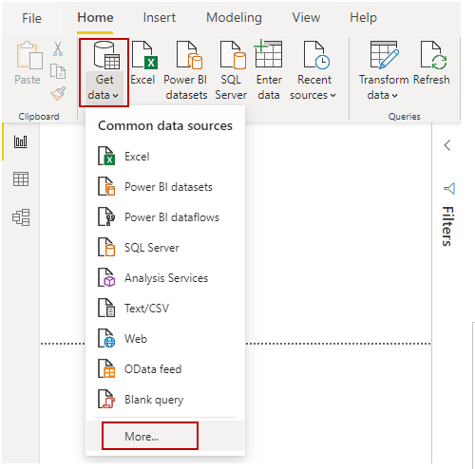

1. Select the type of data source you want to connect to. In this case, **SQL Server** for the R&D team's local server.

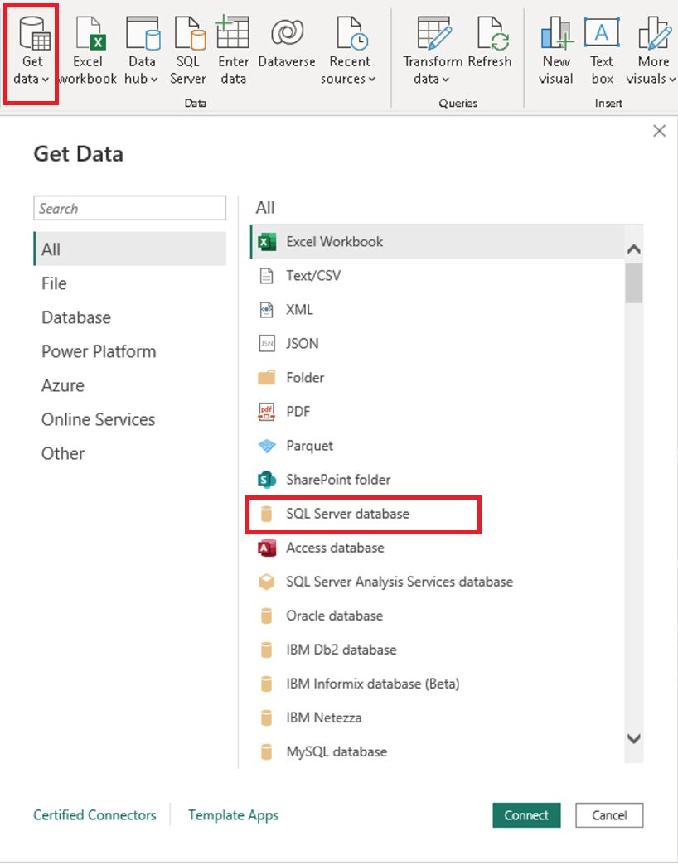

**Step 2: Select the tables to be included**

1. In the SQL Server connection window, enter the server name, database name, and credentials for the R&D team's local server.

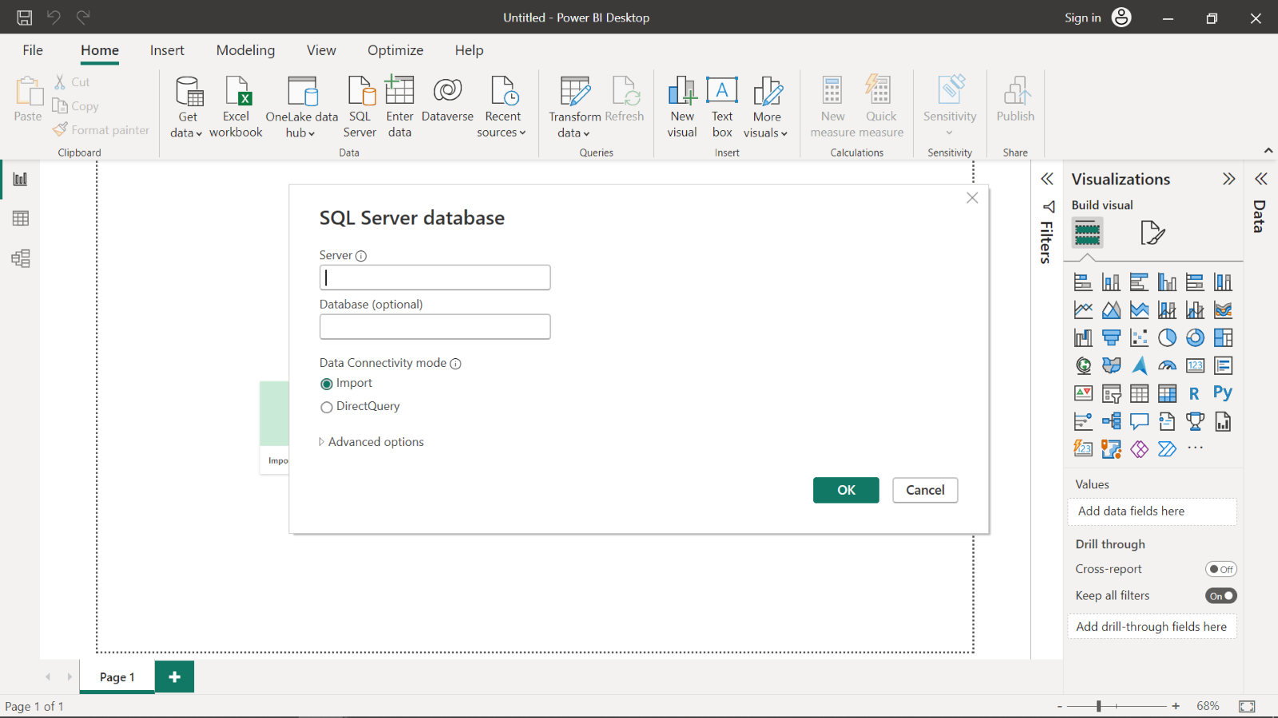

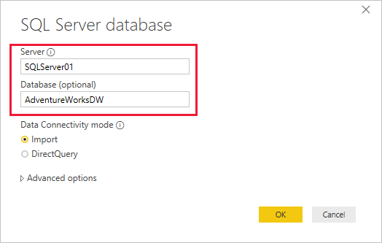

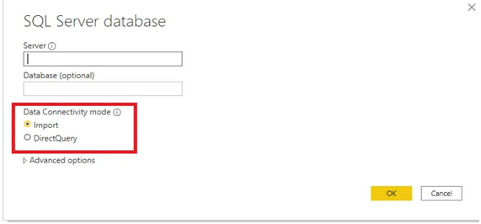

1. To create a report in Power BI, you need to first identify the tables or views that contain HR data for each department and the R&D team. One table that may be relevant for this could be the **Employee** table. To access this table, you can use the list in the **Tables** section on the left-hand side of the **Navigator** window. From there, you can browse through the list of available tables to find the **Employee** table. Select a table to preview its data. If the table contains more columns than can fit on the screen, use the scroll bar on the right side and at the bottom of the **Navigator** window to scroll right or down to display all the available column field names. Look for the column field names that correspond to the required data fields for the report: **Job Title**, **Hire Date**, **Business Entity ID**, **Vacation** and **Sick Leave Hours.**

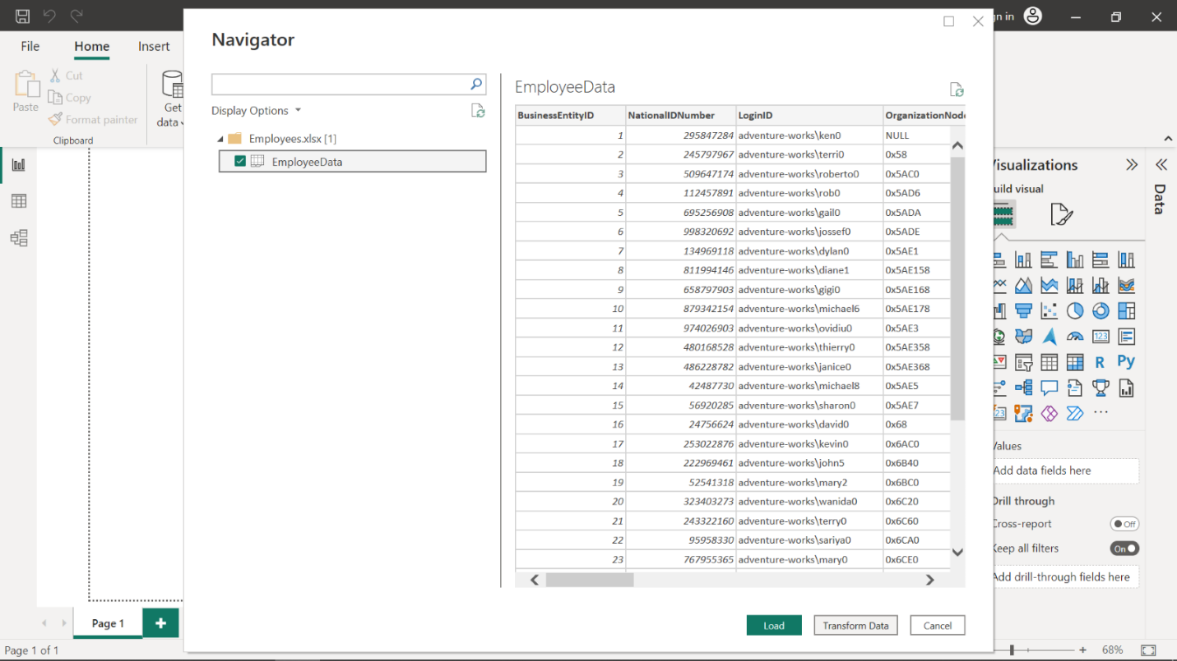

1. Once you have selected the tables you want to analyze, **Employee** table in your case, select **Load** to build a report.

**Step 3: Select the storage mode**

1. To set the storage mode select the **Advance** option in the **Properties** pane and open the **Storage Mode** drop-down menu.

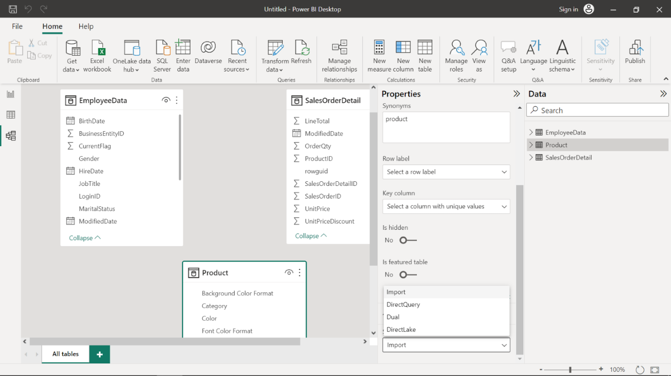

1. Choose the storage mode that best suits your needs. For example, if you want to optimize for faster queries, select Import. Select DirectQuery to connect directly to your data source without having to import the data into Power BI Desktop. This is especially useful for large or frequently changing data sources. **Tip:** It is important to know that once you set the storage mode of a table to Import, it cannot be undone. This is a permanent action, and you won't be able to switch to DirectQuery or Dual modes afterwards.
2. Select **OK** to save the changes.

Congratulations, you have successfully set up a storage mode for your HR data in Power BI. **Tip:** You can go back and revisit [Configuring storage modes in Power BI](https://www.coursera.org/learn/extract-transform-and-load-data-in-power-bi/lecture/UtYKQ/configuring-storage-modes-in-power-bi), at any time.

**Conclusion**

In this step-by-step tutorial, you learned how to set up your storage mode in Power BI. This is a crucial step to improving the performance of your reports and dashboards. You identified that there are two storage modes available in Power BI: Import and DirectQuery. Import is ideal for small to medium-sized datasets, while DirectQuery is recommended for large and complex datasets. You have also learned how to gather data from different sources, transform and clean it, and create relationships between tables. By following these steps, you can generate reports and analyze the data faster and more efficiently to identify the causes of the high employee churn rate.